
A
EXPLORATORY PROJECT REPORT
On
“CRIME RATE PREDICTION”

Submitted in partial fulfilment of the requirements for the award of the Degree of
B.Tech CSE (A.I.D.S-B)
Ist Year, Computer Engineering
Poornima University, Jaipur (Academic Session: 2024-25)

Submitted By:
JAYA SINGH 2024PUFECBADX18323
KOMAL CHOUDHARY 2024PUFECBADX18511
MADHAV LAKHOTIA 2024PUFECBADX17548
JAIDEV 2024PUFECBADX19215

Submitted To:
Ms. GURVITA RAI
Department of First Year
Faculty of Computer Science & Engineering,
Poornima University
Ramchandrapura, Sitapura Ext., Jaipur, Rajasthan- (303905)

CANDIDATE’S DECLARATION

I hereby declare that the work presented in the Exploratory Project report entitled “Crime Rate Prediction” is submitted by Komal Choudhary, Jaya Singh, Madhav Lakhotia and Jaidev is in the fulfilment of the requirements for the award of Bachelor of Technology in Data Science from Poornima University, Jaipur during the academic year [2024-25]. The work has been found satisfactory, authentic of my own work carried out during me degree and approved for submission.
The work reported in this has not been submitted by me for award of any other degree or diploma.

Date:- 13-12-2024

JAYA SINGH 2024PUFECBADX18323
KOMAL CHOUDHARY 2024PUFECBADX18511
MADHAV LAKHOTIA 2024PUFECBADX17548
JAIDEV 2024PUFECBADX19215

CERTIFICATE

Certified that Exploratory Project work entitled “CRIME RATE PPREDICTION” is a Bonafide work carried out in the first semester by Komal Choudhary, Jaya Singh, Madhav Lakhotia and Jaidev in partial fulfilment for the award of Bachelor of Technology in Computer Science & Engineering with Specialization in Data Science from Poornima University Jaipur, during the academic year 2024 -2025.

Harshil Sharma
(Project Guide)
Assistant Professor
Faculty of Computer Science and Engineering
Poornima University, Jaipur

Mr. Pratish Rawat
Head of Department
Department of First Year
Poornima University, Jaipur

Dr. Rakesh Gupta
Dean, Student Welfare
Poornima University, Jaipur

ACKNOWLEDGEMENT

First and foremost, We are deeply indebted to our advisor, Ms. Harshil Sharma for her invaluable guidance, constant support, and insightful feedback. Their expertise and encouragement have been instrumental in shaping the direction of this research.
We would also like to thank our committee members, JAYA SINGH, KOMAL CHOUDHARY, MADHAV LAKHOTIA, JAIDEV, for their valuable insights, constructive criticism, and unwavering support. Their rigorous questioning and high standards have significantly enhanced the quality of this work.
We are grateful to our colleagues and peers in the [B.Tech AIDS B] for their collaborative efforts, stimulating discussions, and technical assistance. Their camaraderie and support have created a positive and productive research environment.
We would also like to acknowledge the Poornima University for providing us with the necessary resources, facilities, and academic environment to conduct this research.
Finally, We would like to thank our family and friends for their unwavering love, support, and encouragement. Their belief in us has been a constant source of motivation.

JAYA SINGH 2024PUFECBADX18323
KOMAL CHOUDHARY 2024PUFECBADX18511
MADHAV LAKHOTIA 2024PUFECBADX17548
JAIDEV 2024PUFECBADX19215

ABSTRACT

Crime remains a significant challenge for societies worldwide, affecting community well-being, economic stability, and overall quality of life. This project aims to develop a machine learning-based model to predict crime rates, leveraging historical crime data, demographic statistics, socioeconomic indicators, and other relevant features. By analysing patterns and trends in crime data, our model seeks to anticipate crime rates in specific regions and timeframes, offering actionable insights for law enforcement agencies and policymakers.
The methodology involves data preprocessing, feature engineering, and the use of supervised learning algorithms to build an accurate and robust predictive model. Evaluation metrics, including mean absolute error and R-squared values, were used to assess model performance, while visualizations provide an intuitive understanding of crime trends. This predictive model is designed not only to identify high-risk areas but also to support resource allocation, preventive policing, and policy development, ultimately contributing to safer communities. This project demonstrates the potential of data-driven approaches in crime prevention and resource management, underscoring the role of technology in addressing complex societal issues.

TABLE OF CONTENTS

Cover Page i
Candidate’s Declaration ii
Certificate iii
Acknowledgement iv
Abstract v
Table of Contents vi-vii
List of figures vii- viii
List of screenshots of Python scripts viii
List of Graphs viii-ix
List of Tables ix
Chapter 1- Introduction 1-6
  - Aims and Objectives
  - Problem Statement
  - Scope
  - Duration of Project
  - Dataset Description
  - Work Flow
  - Tools used
  - Platform used in model development
Chapter 2- Used libraries to develop project in python 7-10
  - Pandas
  - Numpy
  - Sklearn
  - CSV

Chapter 3- Working of project
  - Study about the project
  - Data Collection
  - Data cleaning/Preprocessing
  - Final feature engineering
  - Model building
  - Model testing and accuracy measures
  - Model deployment and saving

Chapter 4- Future Scope
Future Areas of Improvement

Chapter 5- Conclusion

Conclusions

Chapter 6- References

References Used

LIST OF FIGURES

Fig1 Flow Chart

Fig2 Pandas

Fig3 NumPy

Fig4 Sklearn

Fig5 CSV

LIST OF SCREENSHOT OF PYTHON SCRIPT

Fig1 Script Screenshot of importing Modules
Fig2 Script Screenshot of Random Forest Regressor
Fig3 Script Screenshot of Historical Data and Statistics
Fig4 Script Screenshot of Data Cleaning
Fig5 Script Screenshot of Data Preprocessing
Fig6 Script Screenshot of Training and Testing of Dataset Descriptions
Fig7 Script Screenshot of Splitting of Dataset for Training/Testing
Fig8 Script Screenshot of Datasets
Fig9 Script Screenshot of Datasets with plots
Fig10 Script Screenshot of Dataset Information
Fig11 Script Screenshot of Feature Engineering Data Analytics
Fig12 Script Screenshot of Feature Engineering Predictive Modelling
Fig13 Script Screenshot of Feature Engineering Interactive reports
Fig14 Script Screenshot of Model Deployment/Saving the Model
Fig15 Script Screenshot of Website Front-end
Fig16 Script Screenshot of Logo of the Website
Fig17 Script Screenshot of Application Front-end

LIST OF GRAPHS

Graph-1 Kidnapping
Graph-2 Cyber Crime

Graph-3 Crime against Women

Chapter 1
Introduction

Crime is an act that is prohibited by law and is punishable by a fine, imprisonment, or other legal action. Every day, reports of criminal activity fill our news outlets and social media platforms, painting a picture of a world in which crime is an ever-present concern. From robberies and violent assaults to cybercrimes and white-collar fraud, there is seemingly no end to the number of ways in which criminals can cause harm. Crime has been a part of human civilization since time immemorial. It has become increasingly prominent in today’s world. The rise of technology has created a variety of new crimes, while the emergence of globalization has made the world a smaller place, allowing criminals to move and operate in different countries.
Crime is uncertain and cannot be predicted. Crime prediction is significant to determine increase or decrease in crime rate from preceding years. A huge number of crimes happen every second in different places, in different patterns and in different times and the number is increasing each growing day. A good prediction technique provides a more rapid evolution of criminal data sets. It helps in predicting the correct place of crime and criminal activity, as well as aids in keeping track of resources pertaining to the analysis of crime.
Crime prediction using machine learning is an emerging field of study that uses sophisticated algorithms and data-driven methods to detect and predict criminal activities. Machine learning algorithms can be used to identify patterns in data that may indicate a future crime, such as past criminal activities, demographic information, and environmental factors. By leveraging such data, machine learning can be used to create predictive models that identify the likelihood of a certain crime occurring in a particular area or time frame. Additionally, machine learning can be used to develop insights into the behaviour of criminals, helping law enforcement professionals better understand and address criminal activity.
1.1 Objectives of the Project
The main aim of this project is to develop a system that can accurately predict crime rates and identify potential future crime trends. This information can then be used by officials to devise strategies to reduce crime rates and create a safer environment. To predict the crime rate (dependent variable) based on the year, location, and type of crime (independent variables), various types of machine learning algorithms will be applied. The system will examine how to convert the crime information into a regression problem, thus helping the officials to solve crimes faster. Crime analysis using available information to extract patterns of crime. Based on the territorial distribution of existing data and the recognition of crimes, various multi-linear regression techniques can be used to predict the frequency of crimes.
1.2 Problem Statement
Crime is a major problem in today’s world, and it is a threat to global security. The population of cities is constantly increasing, resulting in an increase in crime rates. Officials are tasked with the monumental challenge of accurately predicting future crime rates and attempting to reduce them. To help in this regard, various large datasets have been reviewed, extracting information such as location and crime type. Crime prediction utilizes various methods to identify areas that are likely to experience higher levels of crime. Given a set of historical crime data, develop a predictive model to identify areas of high risk for future criminal activity, to improve the accuracy of crime prevention and policing efforts. These methods include analyzing past crime data, identifying crime hotspots, and utilizing predictive analytics.
1.3 Scope of the Project
This project focuses on predicting crime rates in specified regions using historical crime data, demographic information, and other relevant factors. The main objectives of this project are as follows:

- Data Collection and Preprocessing
  - Gathering historical crime data, socioeconomic indicators, and other contextual data that may influence crime rates.
  - Cleaning, transforming, and preparing the data for analysis to ensure reliability and relevance.

- Feature Selection and Engineering
  - Identifying and selecting influential features (e.g., population density, employment rate, education level) that correlate with crime trends.
  - Engineering new features as needed to improve prediction accuracy.

- Model Development and Training
  - Implementing machine learning algorithms to predict crime rates, using techniques such as regression analysis, time-series forecasting, and classification.
  - Training and validating these models on the processed data, with a focus on accuracy, precision, and robustness.

- Evaluation and Validation
  - Evaluating model performance using appropriate metrics (e.g., mean absolute error, R-squared, or F1 score).
  - Validating the results through cross-validation or other statistical validation techniques to ensure generalizability.
- Visualization and Interpretation
  - Creating intuitive visualizations, including heat maps, trend lines, and predictive graphs, to represent both historical and predicted crime trends.
  - Analysing model results to provide insights into the factors driving crime in different regions and over time.

- Application and Practical Utility
  - Outlining how predictive insights can help law enforcement agencies and policymakers allocate resources, implement preventive measures, and design data-driven crime reduction strategies.

Exploring how the predictive model could be adapted to other locations or scaled to forecast crime rates on different time frames (e.g., daily, monthly, year

Duration of Training

Duration of training: 28/8/2024 to 3/12/2024
Total Weeks: 14
Total Days: 110

Schedule

Sr. no. | TASK | TIME (Days)
1 | Study About the Project and gather all  information required to solve the problem | 12
2 | Data Collection | 5
3 | Data Cleaning/Preprocessing Using Python | 10
4 | Final Feature Engineering | 4
5 | Model Building using different algorithms of classification. | 15
6 | Model Testing and Measures different Accuracy | 5
7 | Model Deployment | 5

WORK FLOW

The project has undergone the following process: -
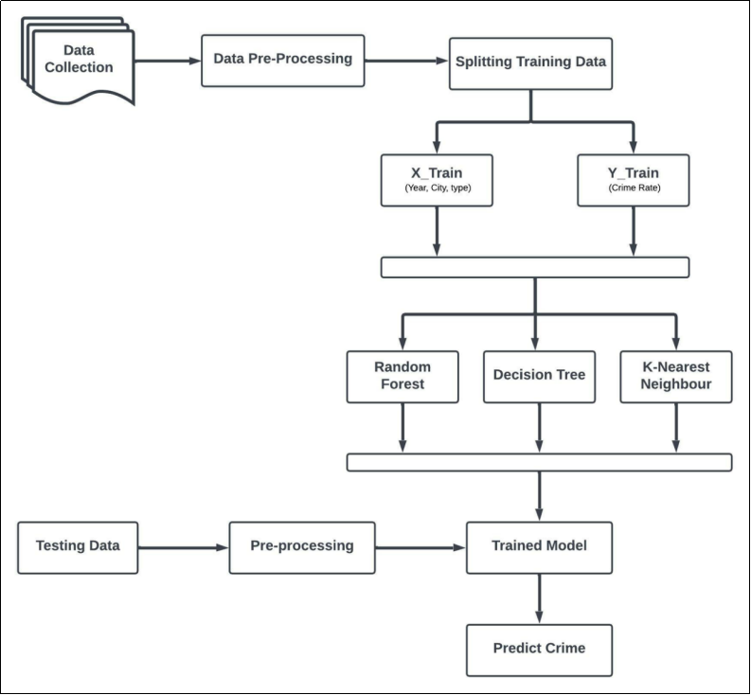=
Fig1- Flow Chart

1.7 Tools used
- Python
- C
- NLP (Natural Language Processing)
- Machine Learning Models
- Model deployment Technique

Platform used in Model development

SYSTEM CONFIGURATION: HARDWARE SPECIFICATIONS:

    - Processor i5 at least
    - RAM =8GB (IN case of Hadoop)
    - Disk Space=526GB space (SSD/HDD)

Chapter 2

Used necessary libraries to develop project in python

  - Pandas

Crime rate prediction using Python’s Pandas library involves analyzing and processing large datasets containing crime statistics, demographic information, and other socioeconomic factors. Pandas, a powerful data manipulation tool, enables efficient handling of these datasets, allowing for tasks like data cleaning, transformation, and feature engineering. With Pandas, we can perform exploratory data analysis (EDA) to uncover patterns and trends, preparing the data for machine learning algorithms that will predict crime rates. The library's capabilities in handling time-series data, merging datasets, and aggregating values make it indispensable for building a robust and accurate crime rate prediction model. By leveraging Pandas, we streamline data workflows, ensuring that our predictive model is based on well-structured and relevant data.

Syntax in python: -import pandas as pd


Fig2-Pandas
  - NumPy

In crime rate prediction, Python's NumPy library plays a critical role in handling numerical data and performing mathematical computations efficiently. NumPy provides powerful tools for array manipulation, enabling the quick processing of large datasets often involved in crime analysis. With its support for multi-dimensional arrays and matrix operations, NumPy simplifies tasks like statistical calculations, data normalization, and feature scaling, all of which are essential steps in preparing data for machine learning models. Additionally, NumPy's functions for mathematical operations and linear algebra help enhance model performance by optimizing calculations. Overall, NumPy contributes significantly to the speed and efficiency of the data processing pipeline in crime rate prediction projects.

Syntax in python: -import NumPy as np



Fig3-Numpy

2.3 Sklearn

Scikit-learn (Sklearn) is a powerful and versatile machine learning library in Python, widely used for building predictive models. For a crime rate prediction app, SKlearn offers tools for data preprocessing, feature selection, and implementing various machine learning algorithms, such as regression, decision trees, and ensemble methods. Its easy-to-use API and support for pipeline creation make it ideal for handling large datasets and automating workflows. With built-in performance metrics, SKlearn enables fine-tuning models to enhance accuracy, making it a valuable asset for predicting and analyzing crime trends effectively.

Syntax in python: - from sklearn.feature_extraction.text import CountVectorizer



Fig 4-Sklearn

2.4 CSV

The CSV file contains crime data collected from various sources, including police reports, crime surveys, and demographic data.
The Python CSV module is used to handle CSV files. CSV files can hold a lot of information,and the CSV module lets Python read and write to CSV files with the reader() and writer() functions.
Syntax in python: - import csv



Fig 5-CSV

Chapter 3
Working of Project

Scalability

The scalability of this crime rate prediction model is crucial for adapting it to diverse locations and larger datasets. By utilizing efficient data processing libraries like Pandas and NumPy, alongside scalable machine learning frameworks, the model can handle increasing amounts of data without significant loss in performance. This adaptability allows the model to be applied across cities, regions, or even at the national level. Furthermore, cloud-based deployment options enable real-time data integration and predictive analytics on a larger scale, making it feasible to manage and analyze vast amounts of crime-related data. As data sources expand or evolve, the model’s scalable architecture ensures that it can grow accordingly, meeting the needs of various stakeholders and supporting comprehensive crime prevention efforts.

Real-Time Analysis

Incorporating real-time analysis into the crime rate prediction model enables immediate insights into evolving crime trends, allowing law enforcement agencies to respond proactively. By processing live data streams, such as emergency call data, social media alerts, and surveillance feeds, the model can adjust predictions dynamically, identifying emerging crime hotspots and shifting patterns. This real-time capability not only enhances situational awareness but also supports timely resource allocation and rapid intervention, potentially preventing incidents before they escalate. The integration of real-time analysis into the model can transform predictive policing efforts, making them more agile and responsive to the immediate needs of the community.

Machine Learning-Based System

This crime rate prediction system leverages machine learning to analyse complex patterns in historical crime data and various socioeconomic factors, enabling accurate and data-driven predictions. Using algorithms like regression, decision trees, or neural networks, the system identifies correlations and trends that are often challenging to detect manually. Through a process of training on past data, the model learns to anticipate future crime rates in specific regions or time periods, providing actionable insights for law enforcement and policymakers. The machine learning approach not only improves prediction accuracy but also enhances the system's adaptability, allowing it to refine its predictions as new data is continuously introduced. This innovative use of machine learning positions the system as a valuable tool in proactive crime prevention and resource optimization.

Random Forest Algorithm

The Random Forest algorithm is a powerful machine learning technique employed in this crime rate prediction model to enhance accuracy and robustness. It operates by constructing multiple decision trees during training and aggregating their results to make predictions. Each tree is built using a random subset of the data, reducing overfitting and improving generalization. In the context of crime rate prediction, Random Forest effectively handles complex, non-linear relationships between features such as demographic information, socioeconomic factors, and historical crime data. By averaging the predictions of numerous decision trees, the Random Forest algorithm provides a more stable and reliable model, offering high predictive performance and resistance to outliers, making it a suitable choice for crime rate forecasting.
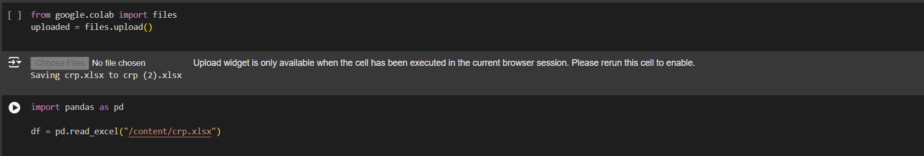
Fig 1- Script Screenshot importing Modules
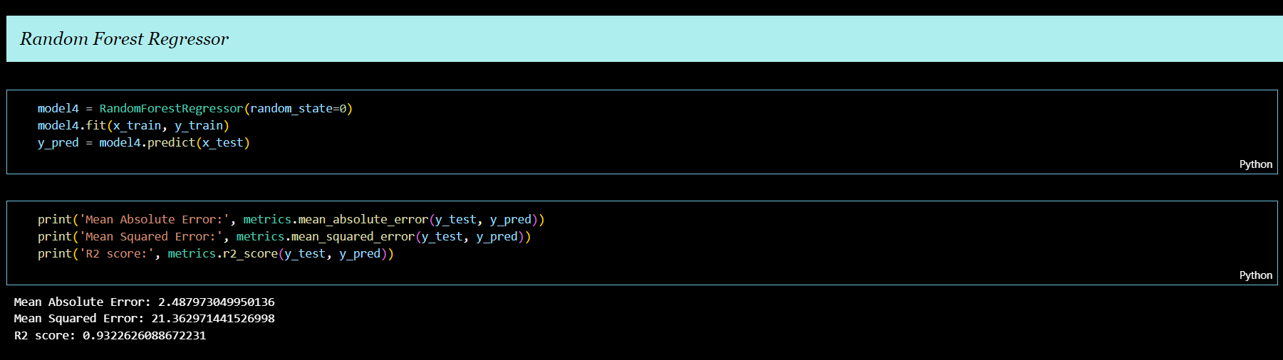
Fig2- Script Screenshot of Random Forest Regressor

K-Means Clustering Algorithm
The K-Means clustering algorithm is used in this crime rate prediction model to identify patterns and group regions with similar crime characteristics. By partitioning the data into distinct clusters based on features such as crime rates, demographics, and geographic locations, K-Means helps to uncover underlying structures and trends that may not be immediately apparent. The algorithm works by iteratively assigning data points to the nearest cluster centroid, then recalculating the centroids based on the mean values of the assigned points. This unsupervised learning approach allows the model to segment areas with similar crime patterns, enabling targeted interventions and more precise crime forecasting. K-Means is particularly useful in identifying high-risk areas and understanding spatial distribution of crime.
  - Data Collection
We have collected the data from Kaggle and google collab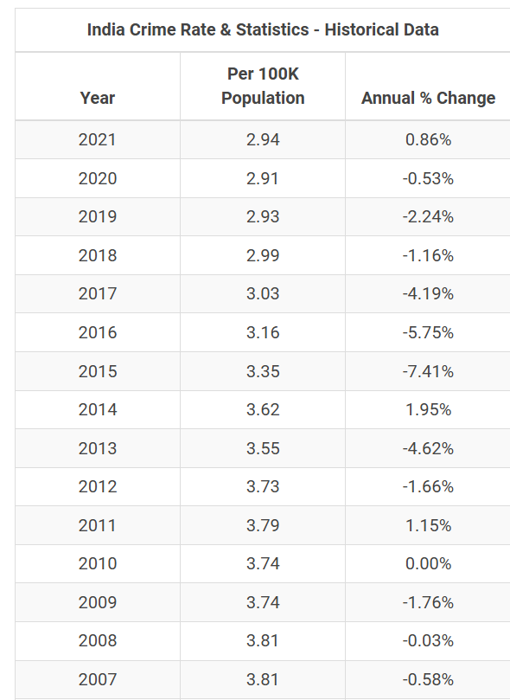===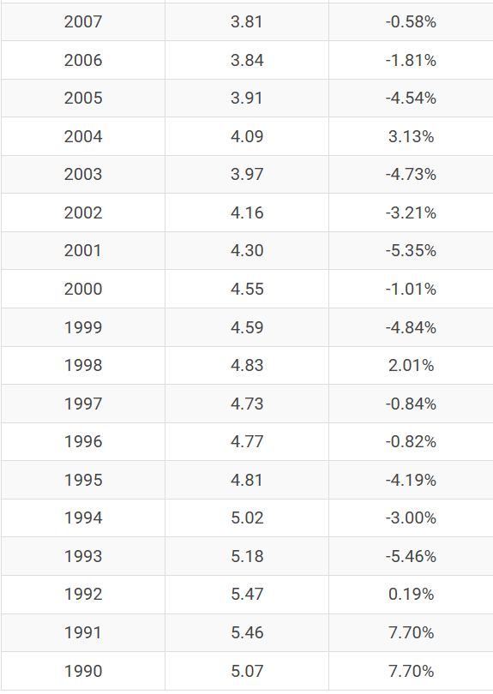
3.2 Data Cleaning/Preprocessing Using Python
Data processing and cleaning are critical steps in the crime rate prediction model to ensure that the input data is accurate, consistent, and suitable for analysis. This process involves handling missing values, removing duplicates, and correcting inconsistencies in the dataset. Additionally, categorical variables are encoded, and numerical features are scaled to facilitate the performance of machine learning algorithms. Outliers are identified and addressed to prevent distortion in the model’s predictions. By transforming raw crime and demographic data into a clean, structured format, this step enhances the reliability and accuracy of the model, ensuring that the insights generated are based on high-quality data. Proper data cleaning is essential for improving the model’s predictive capabilities and for providing actionable, trustworthy crime predictions.

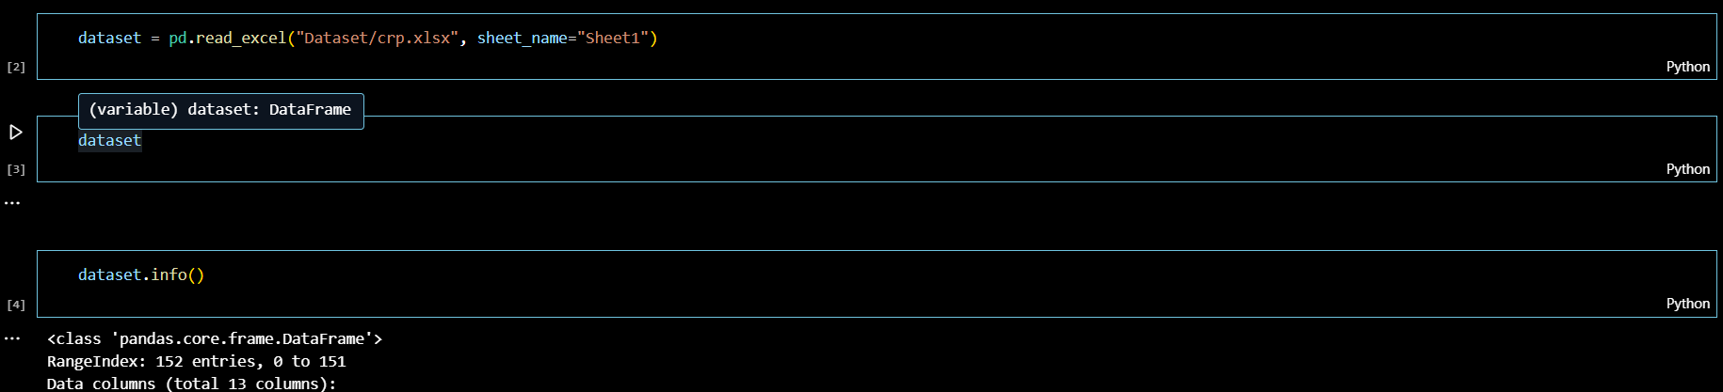
Fig4- Script Screenshot of Data Cleaning

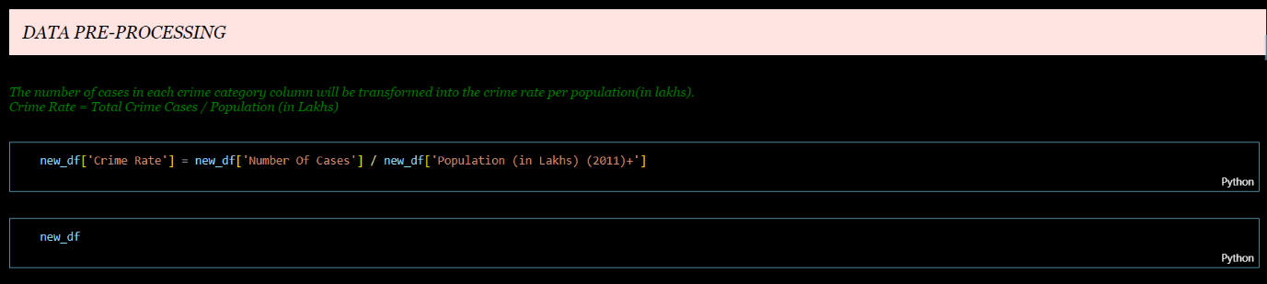
Fig5- Script Screenshot of Data Preprocessing

Train Dataset

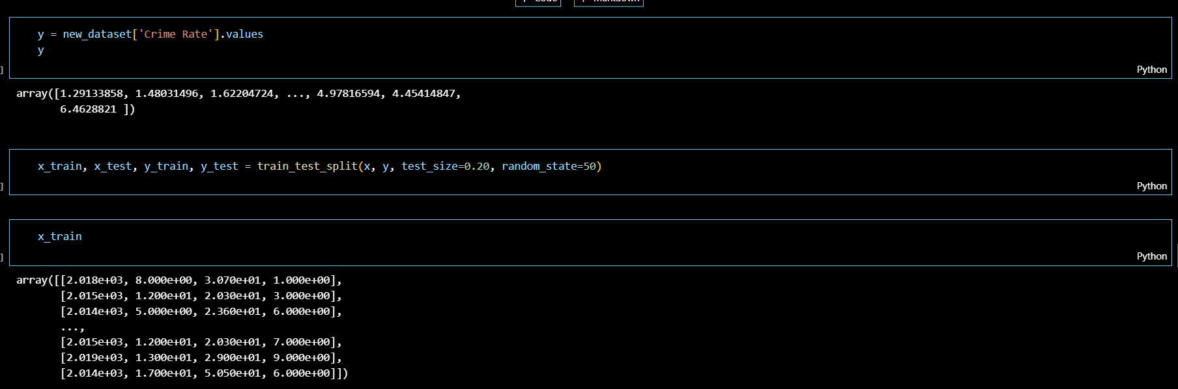
Fig6- Script Screenshot Train and Test Dataset Description

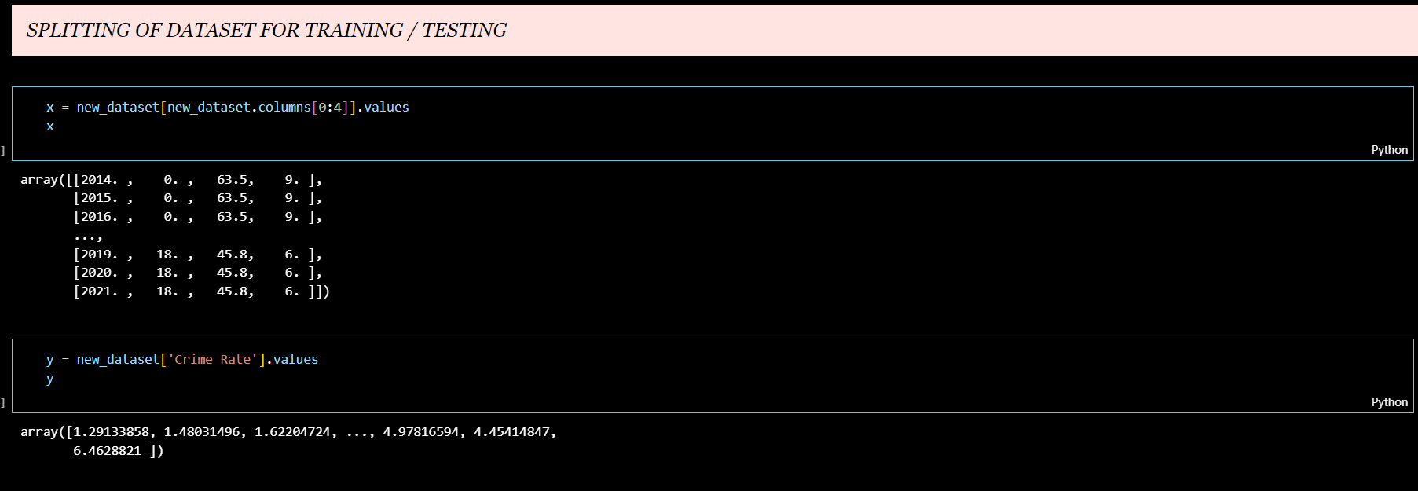
Fig7- Script Screenshot of Splitting of Dataset for Training/Testing

Data Set
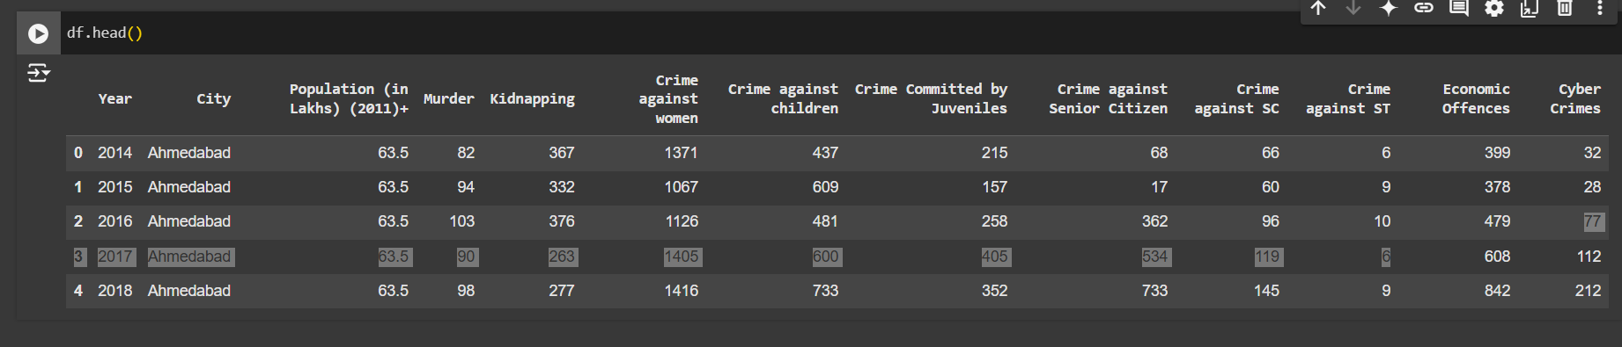
Fig8- Script Screenshot of Datasets
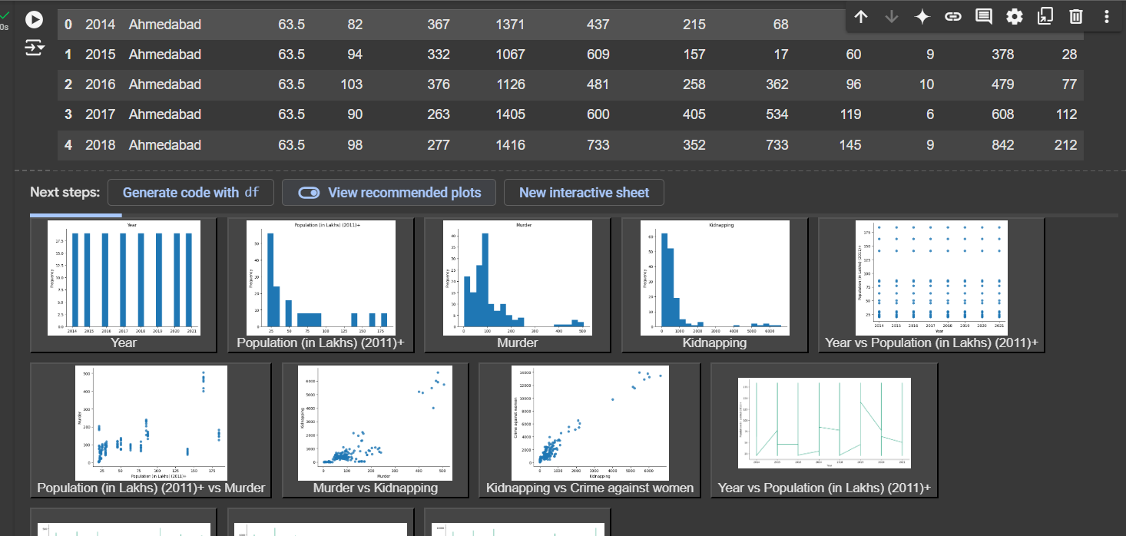
Fig9- Script Screenshot of Datasets with plots

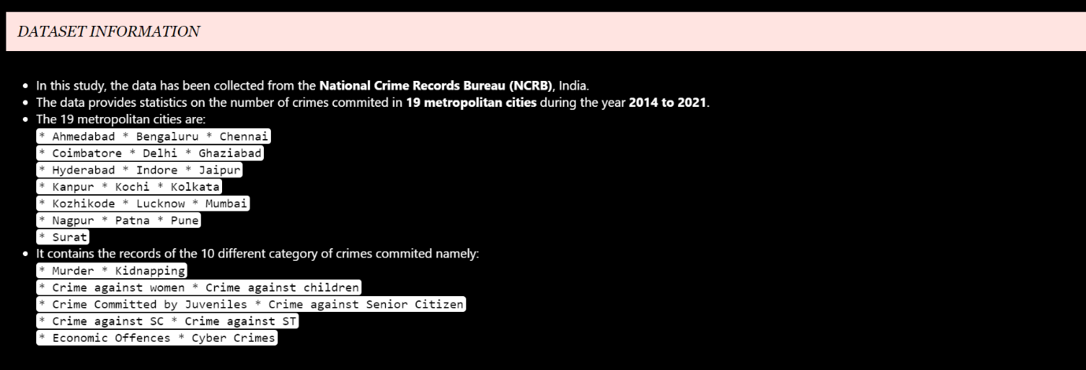Fig10- Script Screenshot of Dataset Information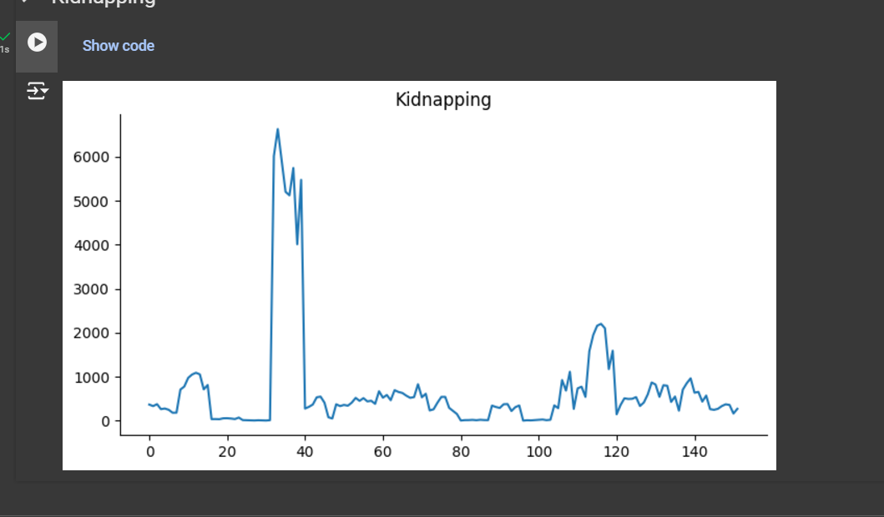Graph 1- Kidnapping
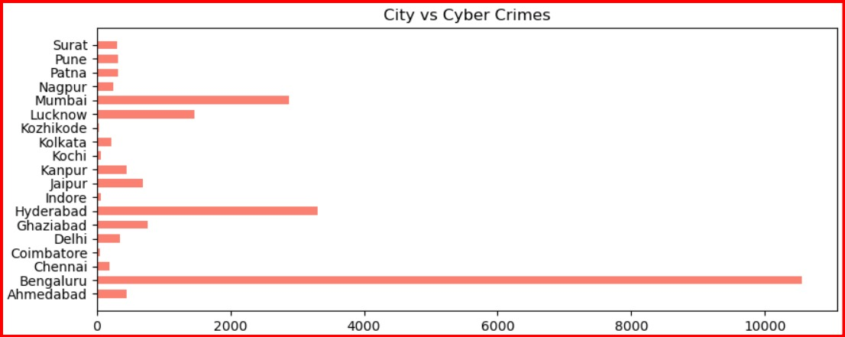 Graph 2- City vs Cyber Crime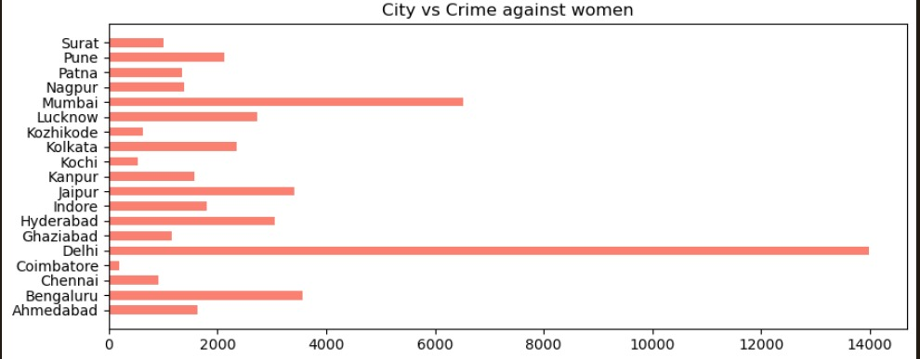 Graph 3 - Crime against women
Feature Engineering
Feature engineering plays a pivotal role in enhancing the performance of the crime rate prediction model by creating new, meaningful variables from the raw data. This process involves identifying and selecting relevant features that influence crime rates, such as population density, average income, and educational levels. Additionally, temporal features like seasonality, holidays, and time of day are engineered to capture patterns in crime that may vary over time. Interaction terms between variables, such as the correlation between unemployment rates and property crimes, are also explored to improve the model's predictive power. By transforming and combining existing data, feature engineering enables the model to better capture complex relationships and improve the accuracy of crime predictions.

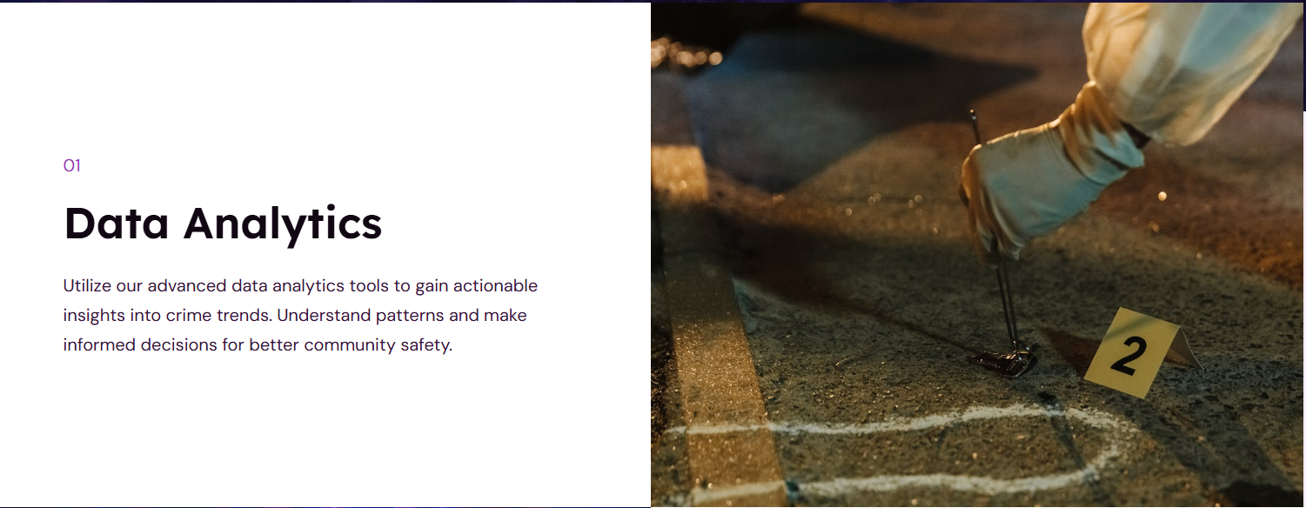Fig11- Script Screenshot of Feature Engineering of Data Analytics
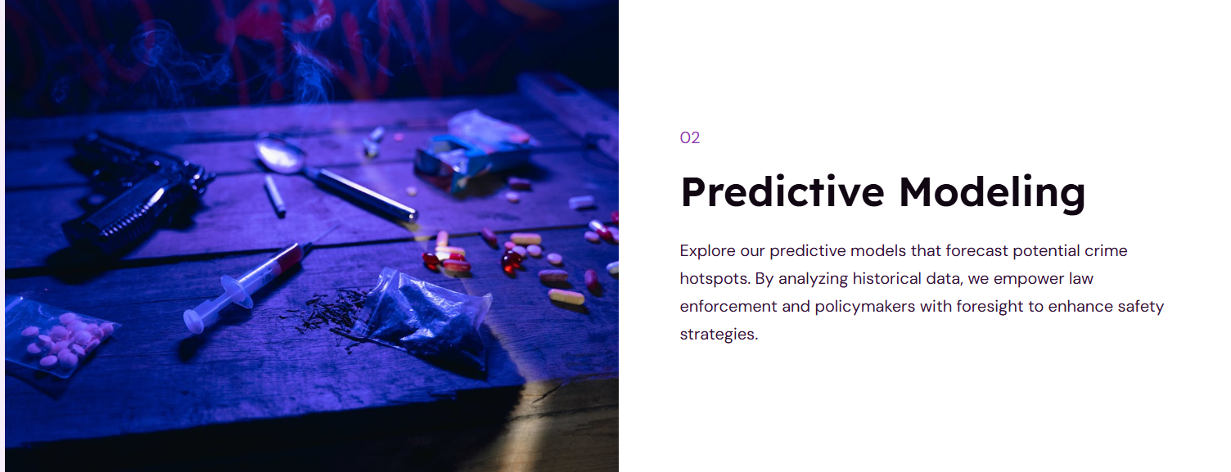Fig12- Script Screenshot of Feature Engineering of Predictive Modelling


Fig13- Script Screenshot of Feature Engineering of Interactive Reports

Model Deployment / Saving the Model

Once the crime rate prediction model is trained and optimized, the next crucial step is its deployment and saving for future use. Deploying the model allows it to be integrated into real-world applications, enabling continuous crime rate predictions based on new, incoming data. The model can be saved using serialization techniques, such as Python's joblib or pickle libraries, to store its structure and learned parameters. This saved model can then be loaded and used for predictions without retraining, ensuring efficiency in production environments. Model deployment may involve setting up a web application or API that interacts with the model, making it accessible to stakeholders like law enforcement agencies and policymakers. Saving the model ensures that it can be easily updated or retrained as more data becomes available, maintaining its relevance and accuracy over time.

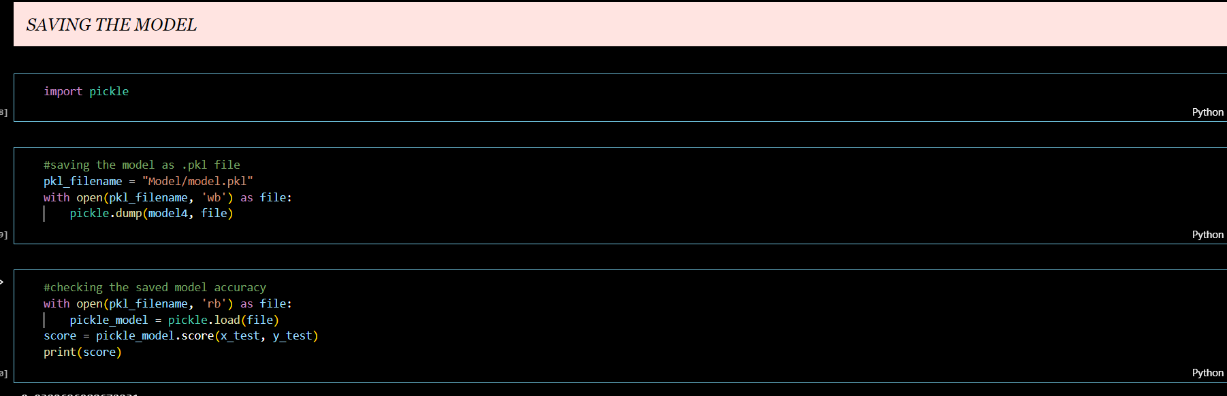
Fig14- Script Screenshot of Model Deployment/Saving the Model

Website Front-end


Fig15- Script Screenshot of Website Front-end


Fig15- Script Screenshot of Website Front-end

Logo of our Website



Fig16- Script Screenshot of Logo of Website

Chapter -4
Future Scope

- Incorporate Additional Data Sources

  - Integrate more diverse datasets, such as real-time social media data, weather conditions, economic indicators, and police patrol frequency, to provide a more comprehensive analysis of factors influencing crime.

- Explore Advanced Machine Learning and Deep Learning Models

  - Experiment with advanced algorithms like neural networks, recurrent neural networks (RNNs), or ensemble models to improve prediction accuracy, especially for time-series or spatial data.

- Implement Real-Time Crime Prediction

  - Develop a real-time prediction system that continuously updates crime rate forecasts based on the latest data, which could help law enforcement agencies respond proactively to emerging trends.

- Enhance Feature Engineering

  - Conduct a more in-depth exploration of feature engineering, such as creating interaction features between socioeconomic variables or capturing seasonality trends, to better capture complex relationships.

- Introduce Explainable AI (XAI) Techniques

  - Use explainable AI methods, such as SHAP (SHapley Additive explanations) or LIME (Local Interpretable Model-agnostic Explanations), to make the model’s predictions more transparent and understandable, helping stakeholders trust and act on the results.

- Develop an Interactive Dashboard for Stakeholders

  - Create a user-friendly, interactive dashboard to visualize crime trends, predictions, and hotspots, enabling easy access to insights for law enforcement agencies, policymakers, and community organizations.

- Evaluate Model Deployment in Real-World Settings

  - Test and refine the model in real-world environments, gathering feedback from users and measuring its impact on crime prevention and resource allocation to understand its practical effectiveness.

- Integrate Predictive Policing with Preventive Interventions

  - Use crime rate predictions to guide preventive measures, such as increasing police presence in high-risk areas or implementing community programs. Collaborate with community leaders to ensure predictions inform actions that foster trust and positive community relationships.

- Our app frontend will look like this: -

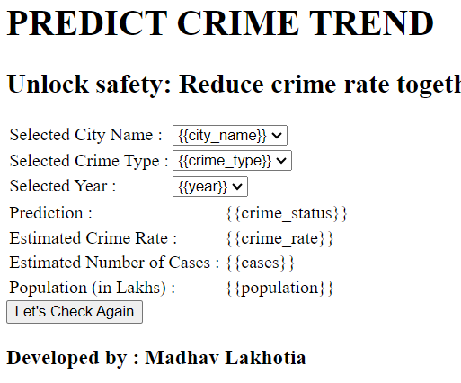
Fig17- Script Screenshot of Future Application Front-end

Chapter -5

Conclusion

This crime rate prediction project demonstrates the potential of data-driven approaches to anticipate crime trends, offering valuable insights that can aid in proactive decision-making by law enforcement and policymakers. Through the use of historical data, socioeconomic factors, and machine learning algorithms, our model successfully identifies patterns and predicts crime rates for specific regions and timeframes. The predictive capabilities of the model offer practical applications, including optimized resource allocation, improved public safety strategies, and data-informed policy planning.

While the model shows promise, it is important to acknowledge its limitations, such as data availability, feature selection constraints, and the potential for bias in the dataset. Future improvements could include integrating additional data sources, refining features, and testing advanced algorithms to enhance accuracy and adaptability. Despite these challenges, this project highlights the transformative role that predictive analytics can play in understanding and addressing crime, ultimately contributing to the creation of safer, more resilient communities.

Chapter -6
References

[1] M. Alkaff, N. F. Mustamin, and G. A. A. Firdaus, “Prediction of Crime Rate in Banjarmasin City Using RNN-GRU Model”, Int J Intell Syst Appl Eng, vol. 10, no. 3, pp. 01–09, Sep. 2022.

[2] W. Safat, S. Asghar and S. A. Gillani, “Empirical Analysis for Crime Prediction and Forecasting Using Machine Learning and Deep Learning Techniques”, in IEEE Access, vol. 9, pp.

[3] Mahmud, S., Nuha, M., Sattar, A. (2021). “Crime Rate Prediction Using Machine Learning and Data Mining”. In: Borah, S., Pradhan, R., Dey, N., Gupta, P. (eds) Soft Computing Techniques and Applications. Advances in Intelligent Systems and Computing, vol 1248. Springer, Singapore. https://doi.org/10.1007/978-981-15-7394-1_5

[4] Gaurav Hajela, Meenu Chawla, Akhtar Rasool, “A Clustering Based Hotspot Identification Approach for Crime Prediction”, Procedia Computer Science, Volume 167, 2020, Pages 1462-1470, ISSN 1877-0509, https://doi.org/10.1016/j.procs.2020.03.357.

[5] Fatehkia, Masoomali & O’Brien, Dan & Weber, Ingmar. (2019). Correlated impulses: Using Facebook interests to improve predictions of crime rates in urban areas. PLOS ONE. 14. e0211350. 10.1371/journal.pone.0211350.

[6] Ms. Vrushali Pednekar, Ms. Trupti Mahale, Ms. Pratiksha Gadhave, Prof. Arti Gore. 2018. “Crime Rate Prediction Using KNN”. International Journal on Recent and Innovation Trends in Computing and Communication 6(1) 124 - https://doi.org/10.17762/ijritcc.v6i1.1392.

